**Game Features**

* Automatic activity update on social website (Facebook, twitter)
* Facebook and twitter synchronizing (likes and friends connection)
* Automatic score ranking of players
* In-app purchase integration (purchasing of coins and lifeline)
* Ad Integration (video and pop up ads)
* Single and Multiplayer game programming
* Multi language (English, Chinese, French) very first screen to appear after the company intro video

**Character**

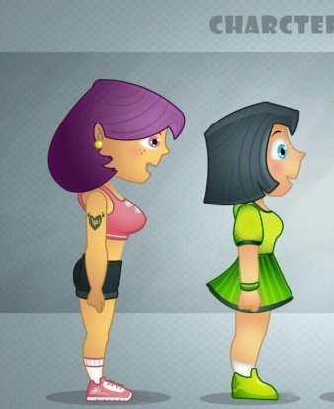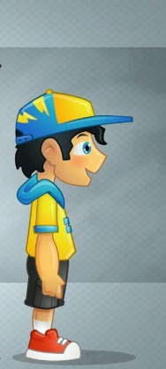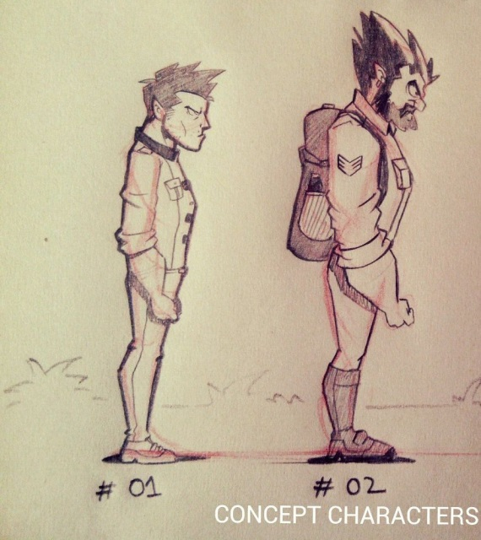

One character will be free while the rest will be locked.

Johny (yellow and blue shirt)- unlocked( free)- normal

Alicia (green cloth)- 10,000 coins- normal

Steve(#01)- 20,000 coins- normal

Zoe (pink with purple hair)- 50,000 coins- normal

Sophie(black girl)- 500,000 coins or 59.99- doubles coins

Zack(#02)-950,000 coins or $129.99- doubles coins and points (x2)

**Splash screen**

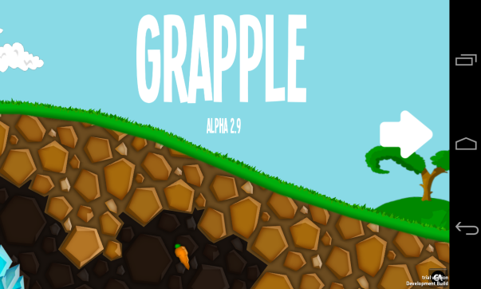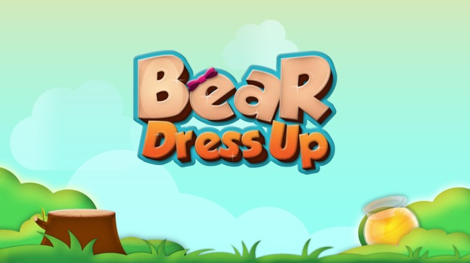

A combination of similar features from the two picture. It should have the game name on the screen. It will have a write-up (“**swipe screen to start**”) at the bottom center below the game name.

**Home screen**

Five option bars: (start, multiplayer, high score, store, settings, quit) facebook and twitter logo at the top. Also a **(follow us on facebook and twitter for more updates)** pop up at the side at intervals(which disappears once the like the page) similar to the one on the sample picture above.

* Start button: leads player to the single-player race
* High score: leads player to the highscore **rating page**  **(please note: we want people to put their email as the submit their score, so we can communicate with the person with the highscore).**
* Store: players can purchase and upgrade in-app features.
* Characters: players purchase characters.
* Settings: player can on/off sound, change language, change username.

**Note:** (no exit option on home screen, See home screen sketch picture for more details.

**Pause screen**

Four option bars: resume, restart, **item bar or store** **(where players can purchase and upgrade their life line and power ups)**, quit and like us on facebook ad pop up at intervals.

**Note:** See pause screen sketch picture for more details.

**Respawn Screen (continue)**

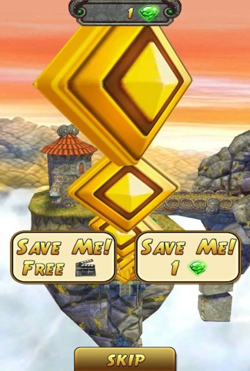

The respawn screen should have only these; **Respawn button (continue)**, **skip** and a **bar showing the amount of diamonds** they have.

**Note:** In a case where the player doesn’t have sufficient diamonds but clicks respawn button, it will take him/her to a **store page** where he can purchase more diamonds or upgrade his power ups. **See single game chart for details**

**Game over screen**

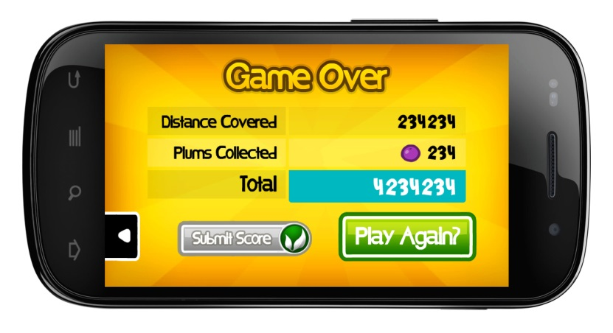

Once you lose, it will take you to **respawn screen (continue).** if you **skip** it will take you to the **Game Over screen,** where you can submit your score or exit. If you click on submit score it will ask you to put your **email**.

**(please note: we want people to put their email as the submit their score, so we can communicate with the person with the hightest score).**

**See single game chart for details**

Ad Networks

1. M media
2. Chartboost
3. Flurry

Ad location

1. After splash screen before home screen.
2. Home screen
3. Pause screen
4. Anytime a player goes back to home screen from any section an ad should pop out
5. Watch video to get coins (100 or 200) in the store section.